## Step One: Run & expose php-apache server

kubectl run php-apache --image=k8s.gcr.io/hpa-example --requests=cpu=200m --expose --port=80

## Step Two: Create Horizontal Pod Autoscaler

kubectl autoscale deployment php-apache --cpu-percent=50 --min=1 --max=10

kubectl get hpa



## Step Three: Increase load

kubectl run -i --tty load-generator --image=busybox /bin/sh

**Hit enter for command prompt**

$ while true; do wget -q -O- http://php-apache.default.svc.cluster.local; done

Open new terminal for the instance

kubectl get hpa

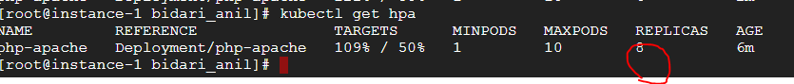

## Step Four: Stop load

We will finish our example by stopping the user load.

In the terminal where we created the container with **busybox** image, terminate the load generation by typing **<Ctrl> + C**.

